Play Store Review Scraper and Analyzer

Submitted by,

Alex Joseph

DT20206479436

**Index**

1. Problem statement……………………………………………………...3
2. Solution…………………………………………………………………..3
3. Architecture Diagram…………………………………………………...4
4. Sequence Diagram……………………………………………………...4
5. Technical Details- versions and license……………………………….5
6. Screenshot of input and output………………………………………...6

**Problem Statement**

Tom wants to Install a new application. He is looking for the best app available. He wants to view the best rated apps from the play store and view their reviews to choose the best one. Build an application to get the best rated Applications for a given category eg. Application name and number of similar apps to be found eg.10, from the playstore with the top reviews.

**Solution**

An application including web scraper and obsei for sentiment analysis and scraping reviews.

The solution includes two parts:

1. Web scraping
2. Review receiver and sentiment analysis

**Web Scraping**

In the web scraping part actually we scrape the play store page with python Beautifulsoup Scraper. And extract the details like heading of the application(the original heading, because the user might’ve given the input in the wrong format or has a spelling mistake or half the heading) ,package name of application, and headings and packages for similar applications

**Review receiver and sentiment analysis**

In Review receiver and sentiment analysis part the package name is passed to the obsei play store scraper and the output is validated for positive negative and neutral comments.

**Architecture Diagram**



**Sequence Diagram**

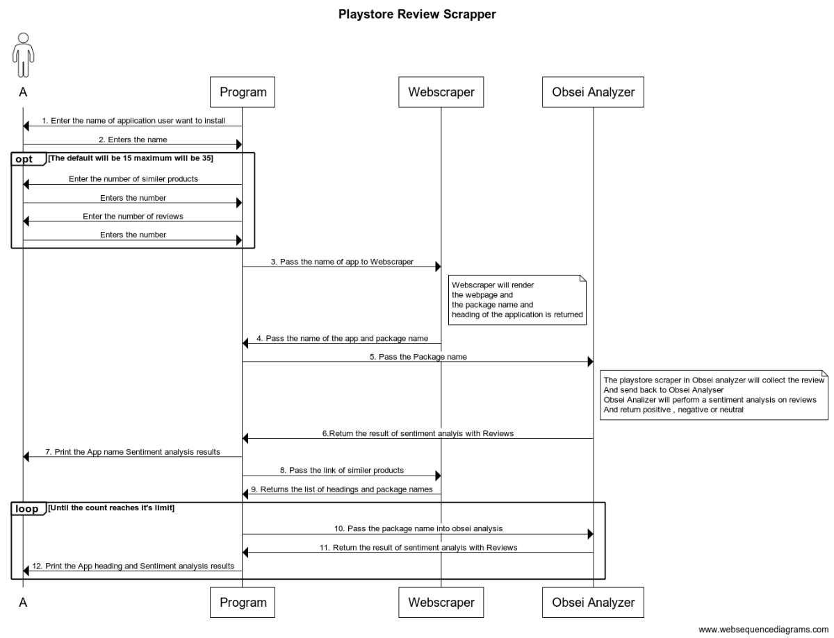

**Technical Details:**

**Tools=**Visual studio code,Jyptr notebooks

**Libraries used:**Obsei

(**License**: Apache Software License (Apache Version 2.0)),

BeautifulSoup4

(**License:** MIT License (MIT))

Requests

(**License:** Apache Software License (Apache 2.0))

*(All library details are available in requirements.txt)*

**Screenshots**

* **Input:**

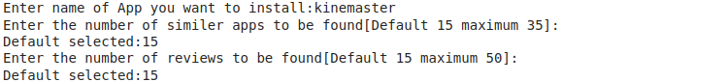

* **Output:**

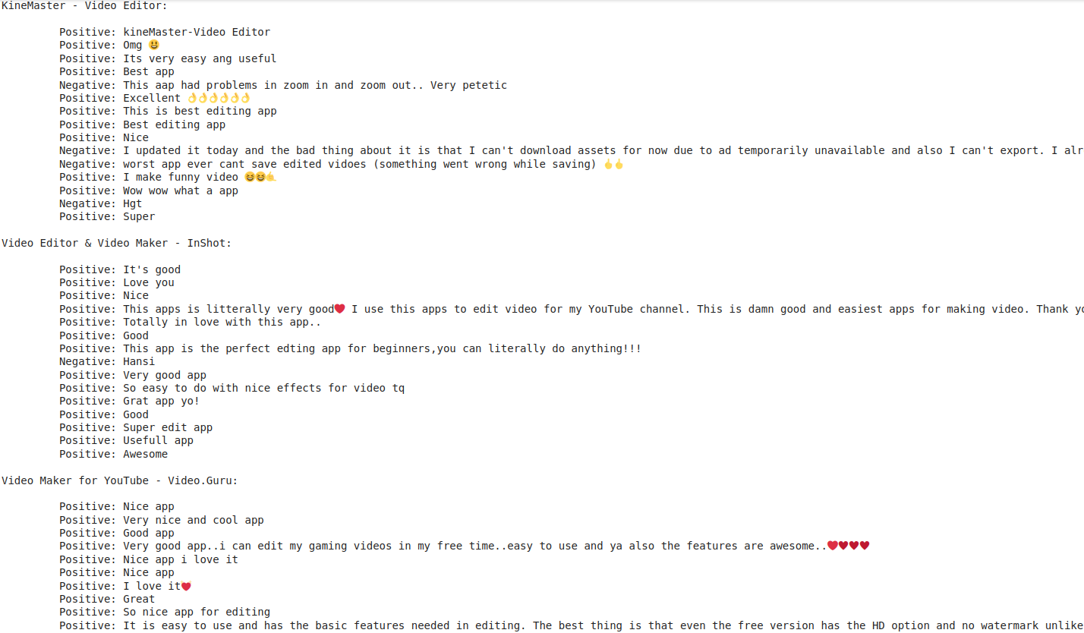

*(Full output is available in Output.txt)*